**Assignment -1**

|  |  |
| --- | --- |
| Student Name | Deepakkumar A |
| Student Roll Number | 612719104015 |
| Maximum Marks | 2 Marks |

**Question-1:**

Create registration page in html with username, email and phone number and by using POST method display it in next html page.

<link rel="stylesheet" href="styles.css" type="text/css">

<div class="login-box">

<h2>Sign Up</h2>

<form action="/login" method="post">

<div class="user-box"><input type="text" id="username" name="username" required=""><label>Enter Username</label></div>

<div class="user-box"><input type="email" id="mail" name="mail" required=""><label>Enter Email id</label></div>

<div class="user-box"> <input type="number" id="number" name="number" required=""><label>Enter contact no</label></div>

<button class="btn" >

<input type="submit" value="SignUp"/></button>

</form>

</div>

from flask import Flask,render_template,redirect, url_for, request app = Flask(__name__)

@app.route('/') def signup():

return render_template('flask.html')

@app.route('/success/<name>/<email>/<contact>') def success(name,email,contact):

# return 'Welcome %s %s %d' % name %email return f'welcome {name} {email} {contact}' @app.route('/login',methods=['POST','GET'])

def login(): if request.method=='POST': user=request.form['username'] eemail=request.form['mail'] contactno=request.form['number'] return redirect(url_for('success',name=user,email=eemail,contact=contactno))

else:

user=request.args.get('username') eemail=request.args.get('mail') contactno=request.args.get('number') return redirect(url_for('success',name=user,email=eemail,contact=contactno))

if __name__ == '__main__':

app.run()

Output:

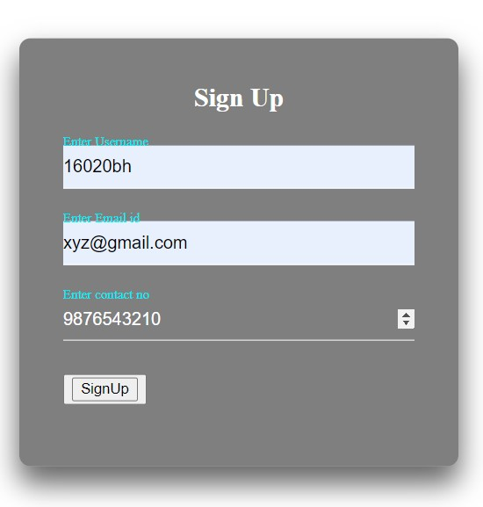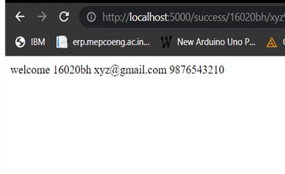

**Question-2:**

Develop a flask program which should contain at least 5 packages used from pypi.org.

import numpy as np import pandas as pd import matplotlib.pyplot as plt import pendulum

from flask import Flask import io

from flask import Response

from matplotlib.backends.backend_agg import FigureCanvasAgg as FigureCanvas from matplotlib.figure import Figure import seaborn as sns

app = Flask(__name__) @app.route('/') def check():

x = 5 y=6 z=np.add(x,y) return ' %d' %z @app.route('/plot') def plot_png():

plt.rcParams["figure.figsize"] = [7.50, 3.50] plt.rcParams["figure.autolayout"] = True

fig = Figure()

axis = fig.add_subplot(1, 1, 1) xs = np.random.rand(100) ys = np.random.rand(100) axis.plot(xs, ys) output = io.BytesIO()

FigureCanvas(fig).print_png(output)

return Response(output.getvalue(), mimetype='image/png')

@app.route('/pandas') def pandas():

ser=pd.Series([0.25,0.7,0.5]) return' %f' %ser[0] @app.route('/seaborn') def seaborn(): fig=Figure() x=[i for i in range(100)] y=[i for i in range(100)]

sns.set() fig,ax=plt.subplots(1,1) sns.lineplot(x,y) img = io.BytesIO()

FigureCanvas(fig).print_png(img)

return Response(img.getvalue(),mimetype='img/png')

@app.route('/pendulum') def pendulum1():

local = pendulum.local(2020, 11,27) zone=local.timezone.name return '%s' %zone

if __name__ == '__main__': app.run()

Output:

1. Numpy package

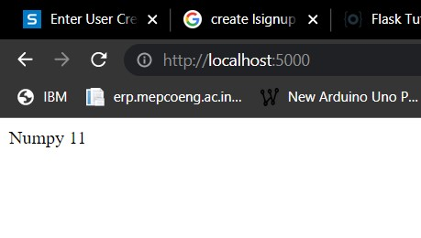

1. Pandas package

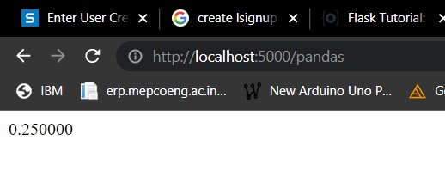

1. Pendulum package

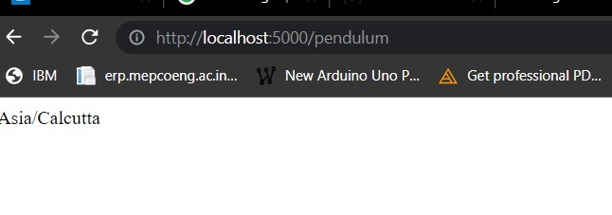

1. using seaborn package

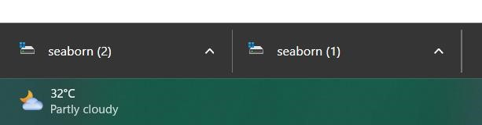

1. Matplotlib package

